MODULE 1B PART B: STUDENT FACTSHEET – SOURCES OF BEEF – DAIRY HERD

The dairy industry is the main source of beef production in Britain. However, calves that originate from the dairy herd are a by product of milk production and when used for beef production they are not always suitable.
Case Study
An imaginary herd of a 100 Friesian Holstein cows (see figurE 1 below) would operate as follows:-
- Cows with the highest dairy quality are bred with a Friesian Holstein Bull
- Cows with lower dairy quality are bred with a beef bull to provide a calf of higher value
- Replacement percentage 20%
- 98% of calves born live
20 replacement heifers would be needed to keep numbers constant (20% replacement percentage). Therefore, considering that one male calf is born for every female calf, a total of 40 cows would need to be sired by a dairy bull to produce the necessary heifers. A side effect of this would be the production of 20 male dairy calves unsuitable for the beef industry. These would probably be culled. 58 beef calves would be produced from the remainder of the herd.
If the herd were given sexed semen to breed replacement heifers, then there would only have to be 20 cows in calf to a dairy bull (Figure 2). This system would produce 78 beef calves and increase the value of the calves produced.

Typical
Friesian Holstein herd
100
cows
20 heifers
Fri/Hol
98 calving
20 male calves
Fri/Hol
29 beef heifers
29 male beef
40 best cows AI
Fri/Hol
58 other cows
BEEF BULL
BEEF INDUSTRY
DISPOSAL
18 cull cows (and bulls)
replacements
2 cow deaths
figurE 1: CASE STUDY OF a DAIRY HERD BREEDING PolICY

Notes
- If the calving period extends beyond 365 days then the proportion of cows bred to AI dairy is likely to increase in order to produce sufficient replacement heifers.
Typical
Friesian Holstein herd
100 cows
20 heifers
Fri/Hol
98 calving
39 beef heifers
39 beef male
20 best cows Fri/Hol
AI sexed semen
78 other cows
BEEF BULL
BEEF INDUSTRY
replacements
18 cull cows (and bulls)
2 cow deaths
FigurE 2 CASE STUDY OF A DAIRY HERD BREEDING POLICY - USING SEXED SEEDS
wHY ARE MILKING ANIMALS OFTEN UNSUITABLE FOR BEEF PRODUCTION?
A link between a Holstein milking cow’s angular shape and a higher milk yield was identified in the USA. Cows with angular shapes were bred at the expense of suitable conformation for beef production. The Holstein’s influence was so substantial that the nature and shape of Friesian cows that were previously suitable for beef calf production, were changed through breeding.
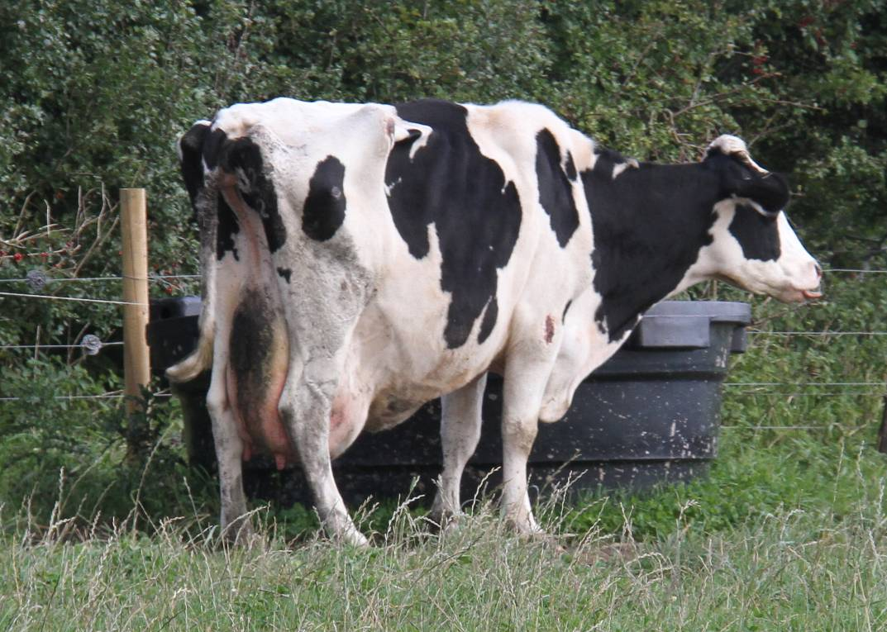
Dairy cow with poor conformation

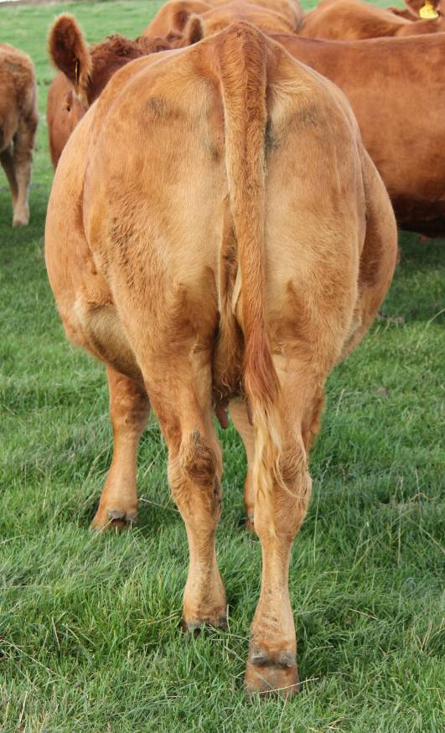
Suckler cow with good conformation

FIGURE 3 BREEDS AND CONFORMATION

beef production from a dairy herd
Since the beef calves are a side effect of milk production in a dairy herd, the beef calves tend to be born in the second calving period.

Calving Herd in Spring
- Dairy calves are born January-March
- Beef calves are born March -May
- During the autumn calf-buying period, the beef calves from the dairy herd will be 5-7 months old – therefore, only the older calves can be finished during the winter period
- The younger calves are finished on grass the following summer.
Calving Herd in Autumn
- Dairy calves are born September-December
- Beef calves are born November-February
- The older beef calves are sold in the spring and finished on grass over the summer
- The younger calves are sold during the summer/autumn period, so that they can be finished during the following winter
Very often, dairy herd objectives will clash with the requirements of producing the perfect calf at the correct time of year.

bull breeds and a description of beef calves that are produced

See: Beef sires for the dairy herd (http://www.hccmpw.org.uk/medialibrary/publications/Beef%20sires%20for%20dairy%20herds.pdf )

